**Existing specification of data exchange between SDU FM and DCSD**

| № п/п | Term, abbreviation | Definition of term / abbreviation |
| --- | --- | --- |
|  | ГЗПО (GZPO) | GZPO State sign of postage - placed in a rectangular frame the name of the state in Russian "РОССИЯ" and in Latin letters "RUSSIA", the word "ПОЧТА" in Russian or Latin letters, a number (at least 7 transferable digits) indicating the amount of payment for postage services communications for forwarding mail, the word "КОП" (denoting an abbreviation for "kopecks"), a number consisting of a conventional letter designation of the manufacturer and the factory serial number of the franking machine or franking module (if the franking machine design provides for a franking module). |
|  | Клиент (Client) | A legal entity that hand over postal items for franking in the Post Office |
|  | Клише франкировальной машины (Cliche of franking machine) | FM memory area, which stores:  - information about the GZPO applied to the postal item to confirm payment for postal services for the transfer of postal items;  - information of the address (inform) cliché FM, containing address and / or other information about the owner (sender of postal items);  - calendar information, including the name, postal code of the place of receipt of postal items, the program for the formation of the current date of receipt;  a program for generating a matrix bar code designed to protect the FM print from counterfeiting. |
|  | Контрагент (Counterparty) | FM Client or Owner. |
|  | ОПС (OPS) | Post Office |
|  | Cliche imprint of franking machine | An image applied to postal items by an FM printing device and corresponding to the information on the form and details of the FM cliché print stored in the electronic memory of the FM. |
|  | ПО (PO) | Software. A computer program or a logically related set of programs designed for automation in a specific area of professional activity. |
|  | СЗД ФМ (SZD FM) | СЗД (SZD) - income protection system using franking machines. |
|  | СДУ ФМ (SDU FM) | FM Remote control system of FM manufacturer is a complex of specialized equipment (hardware and software) of FM manufacturer, which serves to check the FM status, control the advance payment input and the state of controlled registers of each FM connected to the FM remote advance payment system via a secure communication channel, as well as to control special functions of FM and compiling the necessary reports. |
|  | ЦСЗД (CSZD) | Central income protection system (SZD) FM |
|  | ФМ (FM) | Franking machine - a machine designed to apply an FM cliché impression on franked postal items. |
|  | Franking | FM cliche stamping on franked postal items. |
|  | Franked postal items | Domestic and international regular and registered letters, cards and parcels, first class mail, interactive mail. |
|  | HTTP | HyperText Transfer Protocol |
|  | HTTPS | HyperText Transfer Protocol Secure |
|  | FTP | File Transfer Protocol |
|  | FTPS | File Transfer Protocol over SSL |
|  | XML | Extensible Markup Language |

1. Interaction of CSZD (Central income protection system) and SDU FM (FM remote control system) should take place in accordance with the data exchange structure shown in Figure 1.

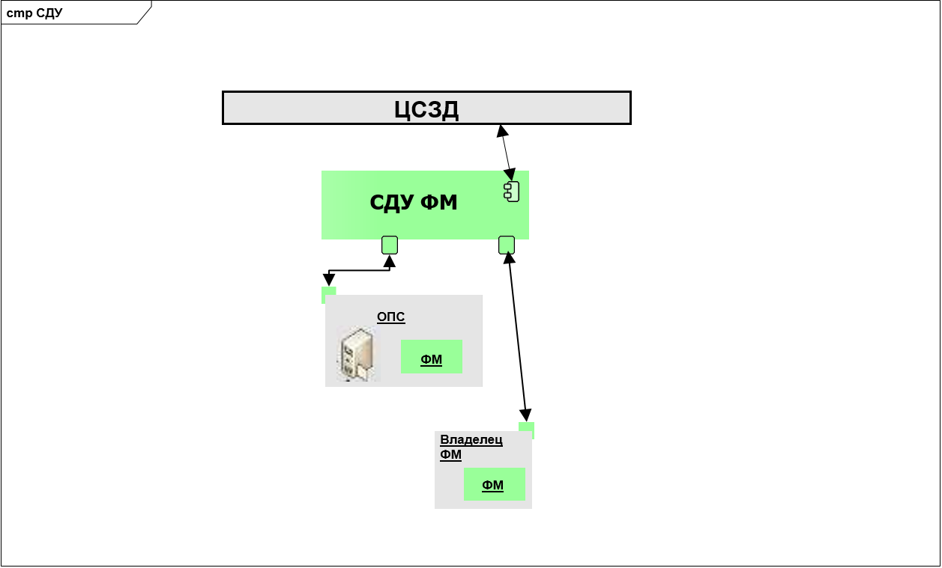

Владелец ФМ – FM owner (private)

ФМ – FM – franking machine

ОПС – Post Office

СДУ ФМ – SDU FM – FM remote control system

ЦСЗД - CSZD – Central income protection system

*Pic.1*

1. SDU FM must interact with the CSZD to confirm the execution of each operation performed on the FM and in the SDU FM. Such operations include:

• registration of a new FM;

• change of FM status;

• changing the address cliché (informal cliché) FM;

• export of the tariff table to the SDU FM and receiving feedback on the import of the tariff table, as well as on the application of tariffs for a specific FM;

• loading and updating the data on the Counterparties in the SDU FM;

• checking the availability of funds on the personal account of the Counterparty in the CSZD;

• exchange of data on franked postal items (with this operation, a batch mode of data exchange is possible, at the beginning and end of a franking job or at the end of a certain time period).

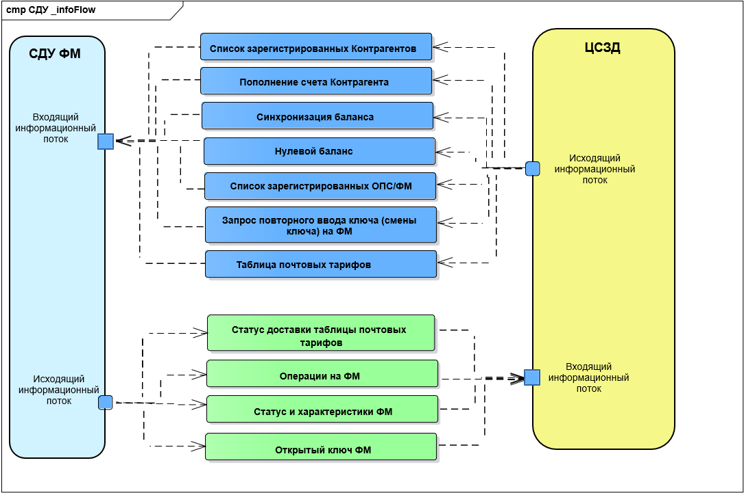

- postage table delivery status

- FM operations

- FM status and characteristics

- public key fm

- list of registered contractors

- completion of the counterparty account

- balance sync

- zero balance

- list of registered post offices / FM

- request to re-enter the key (change the key) FM

- table postal rates

ЦСЗД - CSZD – Central income protection system

Incoming information flow

Outcoming information flow

Outcoming information flow

Incoming information flow

СДУ ФМ – SDU FM – FM remote control system

*Рисунок 2. «Схема информационных потоков между ЦСЗД и СДУ ФМ».*

1. SDU FM should:

- to provide remote control of the FM status through the CSZD (authorized, blocked);

- in the automatic mode, exchange codes and keys with the CSZD to identify the FM (in case of a mismatch in the codes, the FM should be blocked);

- process, save and provide the administrator of the SDU FM with data on technical failures in the operation of the SDU FM and individual FMs, including fault codes and possible ways to eliminate them.

1. Data exchange is carried out by XML-documents in utf-16 encoding. The CSZD-initiator of the exchange sends the original XML-document (message / file), in response, receives a response XML-document. The exchange is carried out through web services (web-service, HTTPS) or secure FTP (FTPS) SDU FM. Each XML response document can contain a description of the error in English and a numeric error code (errorCode).
2. Using XML documents, information about the Counterparties, the Counterparties' funds (including synchronization of the Counterparty's funds in the CSZD and FM, sending a zero amount to FM to block the franking of shipments), OPS (PostOffice), FM (including including FM authorization - permission to use FM in the specified OPS), applicable tariffs, franking transactions.
3. The exchange of information about digital keys FM (digital signature) is also carried out between the CSZD and the SDU FM.

6. In the case of file exchange via FTPS, the file names are structured as follows:

<message_type> <Request / Response> <timestamp> <milliseconds>

For example, CustomerManagementRequest_20170402122526_123 means that this is a Counterparty data transfer request generated on 04/02/2017 at 12:25:26 and 123 milliseconds.

The response XML document matching the request must contain the same timestamp + milliseconds, for example, CustomerManagementResponse_20170402122526_123.

The table below shows examples of traffic messages:

|  |  |  |
| --- | --- | --- |
| **Content of the message** | **CSZD-initiator of the exchange** | **Current name of the message** |
| FM Information | SDU FM -> CSZD | FMManagementPM |
| FM Autorization | CSZD -> SDU FM | FMAuthorizationPM |
| Counterperty Data | CSZD -> SDU FM | CustomerManagementPM |
| Deposit funds | CSZD -> SDU FM | CreditRechargePM |
| Information about funds sent by the SDU FM to FM | CSZD -> SDU FM | CreditRefillPM |
| Franking statistics | SDU FM -> CSZD | FrankingStatsPM |
| PostOffice Information | CSZD -> SDU FM | POManagement |
| FM public keys | СДУ ФМ -> CSZD |  |
| Re-generation of the FM encryption key | CSZD -> SDU FM | ReKey |
| Tariff table | CSZD -> SDU FM | RateTable |
| Feedback on the applied tariff table | SDU FM -> CSZD | RateTableFeedback |